**GMOTORS India Expansion**

**Why SQL**- SQL (Structured Query Language) is a language used for interaction with relational databases.

It provides precise data extraction by giving

* targeted data retrieval (using conditions),
* data filtering (data ranges, specific values),
* data aggregation (sum, avg, count)

It also provides data manipulation and transformation like

* data cleaning (dealing null values),
* data joining (combining data from multiple tables to view at once),
* data transformation (converting datatypes, formatting dates)

Data Analysis (analyze trend, patterns) and data reporting.

**Problem Statement:**

**G Motors** is an automotive giant from the USA specializing in electric vehicles (EV). In the last 5 years, their market share rose to 25% in electric and hybrid vehicles segment in North America. As a part of their expansion plans, they wanted to launch their bestselling models in India where their market share is less than 2%.

Tables that are given to us:

**electric_vehicle_sales_by_state.csv**

* date(dd-mm-yy): Date on which vehicle was sold
* State: Which state the vehicle is sold within India
* Vehicle_category: Whether it is 2-wheeler or 4-Wheeler
* Electric_vehicles_sold: number of EV sold
* Total_vehicles_sold: Total vehicles sold (electric& non-electric) on that date

**electric_vehicle_sales_by_makers.csv**

- date: The date on which the sales data was recorded

- vehicle_category: Whether 2-wheeler or 4-wheeler

- maker: The name of the manufacturer or brand of the electric vehicle.

- electric_vehicles_sold: The number of electric vehicles sold by maker in the given category on the given date.

**dim_date.csv**

- date: The specific date for which the data is relevant. Format: DD-MMM-YY. (Data is recorded on a monthly basis)

- fiscal_year: The fiscal year to which the date belongs. For finance and business purpose

- quarter: The fiscal quarter to which the date belongs. Fiscal quarters are typically divided as Q1, Q2, Q3, and Q4.

Some important parameters in the entire dataset

**Fiscal_year**: April 1st and ending on March 31st

**Penetration Rate**= percentage of a target market or population that adopts or uses a particular product, service, or technology.

(Electric Vehicles Sold / Total Vehicles Sold) * 100

**CAGR**= annual growth rate over a specified period longer than one year

[(Ending Value / Beginning Value) ** 1/n] -1

In order to find answers to the question that arise while solving the problem statement we first need to create a database for GMotors and using it as a default database to use

Syntax for creating one will be-

CREATE schema G_motors;

USE G_motors;

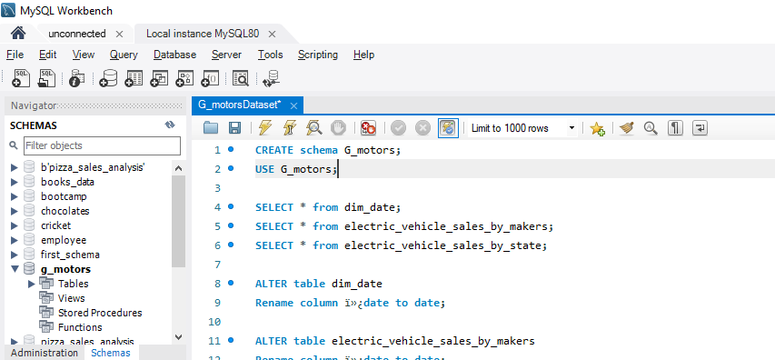

After creating the schema we need to load the files into the database by either using inline function or by using import wizard

* Here I have used Table data Import Wizard

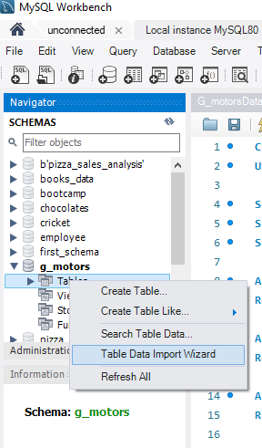

After which we need to provide file path that needs to be imported into our database making it ready to use.

Loading 3 tables into our database:

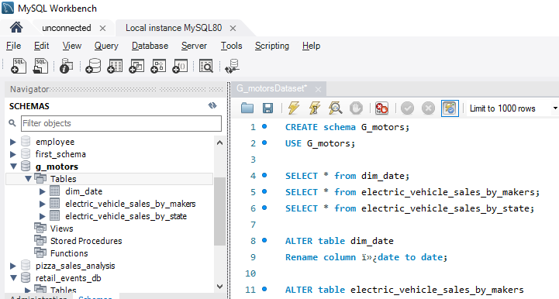



* We have a column name date with some special characters at the beginning it is necessary to rename them so that it will be easier to understand and use

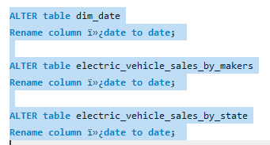

Questions that we need answers for:

1. List the top 3 and bottom 3 makers for the fiscal years 2023 and 2024 in terms of the number of 2-wheelers sold.

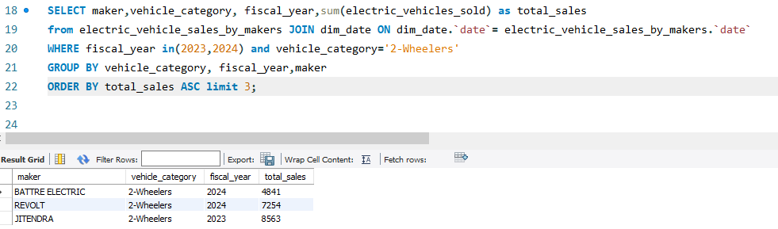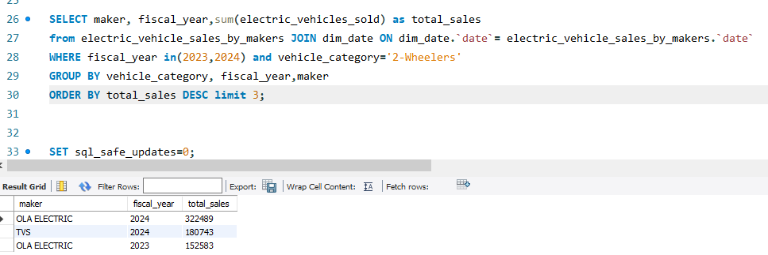

1. Find the overall penetration rate in India for 2023 and 2022

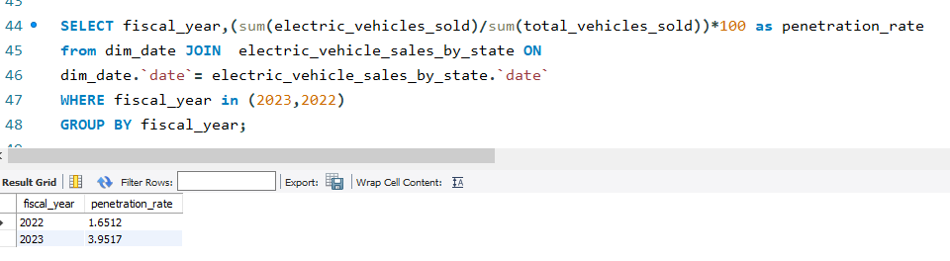

1. Identify the top 5 states with the highest penetration rate in 2-wheeler and 4-wheeler EV sales in FY 2024.

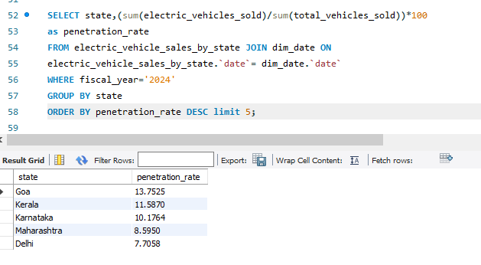

1. List the top 5 states having highest number of EVs sold in 2023

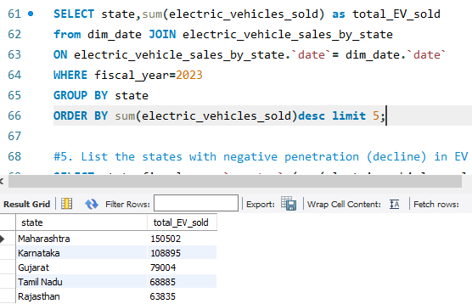

1. Which are the Top 5 EV makers in India?

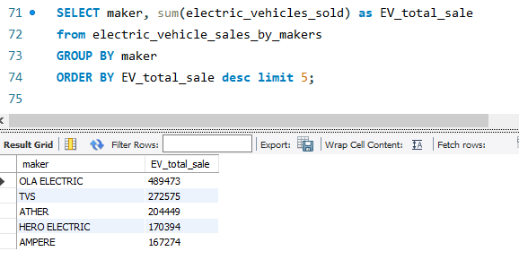

1. How many EV makers sell 4-wheelers in India?

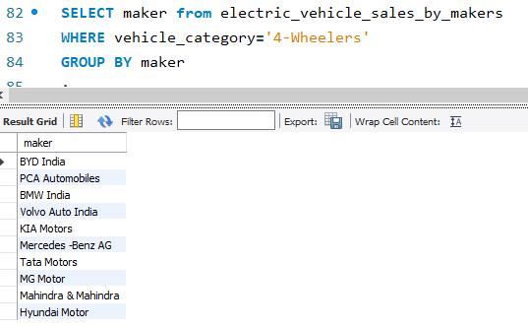

1. What is ratio of 2-wheeler makers to 4-wheeler makers?

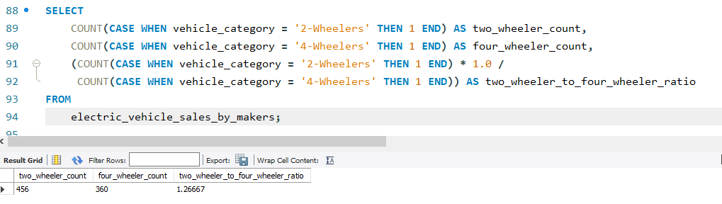

1. How do the EV sales and penetration rates in Maharashtra compare to Tamil Nadu for 2024?

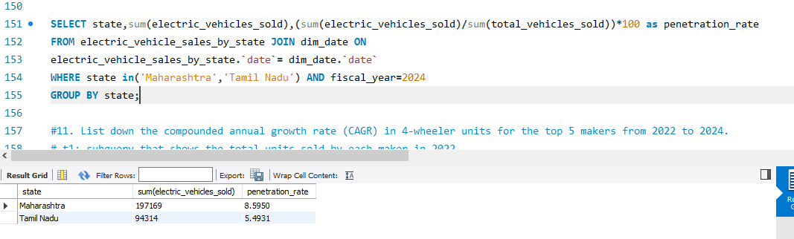

For the following few queries referring to the SQL Workbench

1. What are the quarterly trends based on sales volume for the top 5 EV makers (4-wheelers) from 2022 to 2024?
2. List down the compounded annual growth rate (CAGR) in 4-wheeler units for the top 5 makers from 2022 to 2024.
3. List down the top 10 states that had the highest compounded annual growth rate (CAGR) from 2022 to 2024 in total vehicles sold.
4. What are the peak and low season months for EV sales based on the data from 2022 to 2024?
5. Estimate the revenue growth rate of 4-wheeler and 2-wheelers EVs in India for 2022 vs 2024 and 2023 vs 2024,

assuming an average unit price.

1. List the states with negative penetration (decline) in EV sales from 2022 to 2024?

**FINAL ANALYSIS:**

Invest in- As ratio suggest

|  |  |
| --- | --- |
| 2-wheelers: 456 |  |
| 4-wheelers: 360 |  |
|  |  |

Focus on states with high sale in EV

|  |
| --- |
| * Maharashtra |
| * Karnataka |
| * Gujarat |
| * Tamil Nadu |
| * Rajasthan |
| States with highest CAGR from 2022-2024:   |  | | --- | | * Meghalaya | | * Goa | | * Karnataka | | * Delhi | | * Rajasthan | |